**Project Implementation**

On completing the development part, we then run the application one last time to verify all the functionalities and look for any bugs in it. The user interface of the application looks a bit like the one’s provided below.

* **Landing Page**

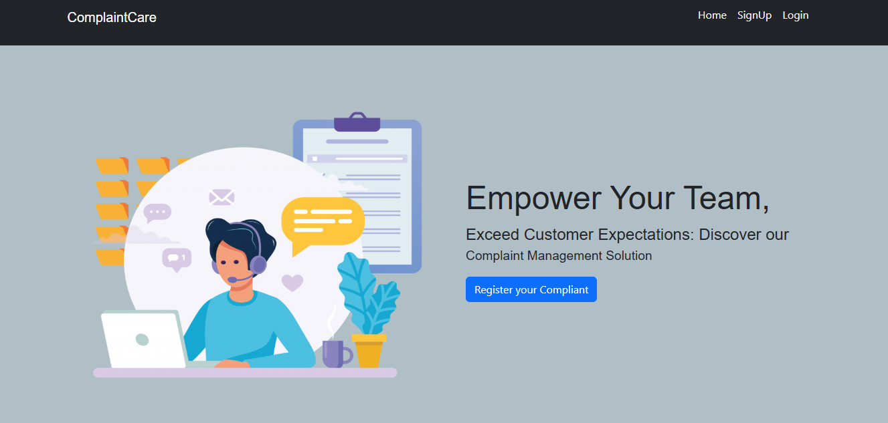

* **Login Page**

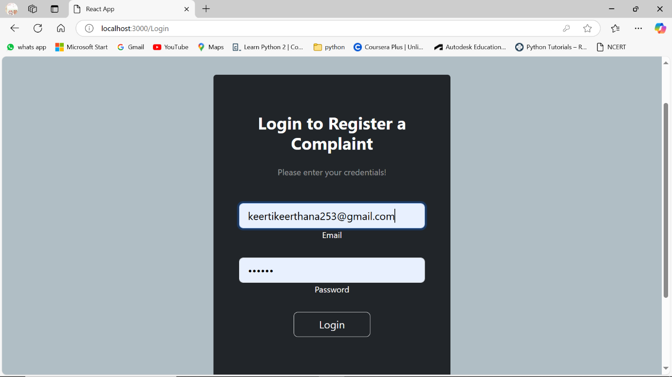

* **Registration Page**

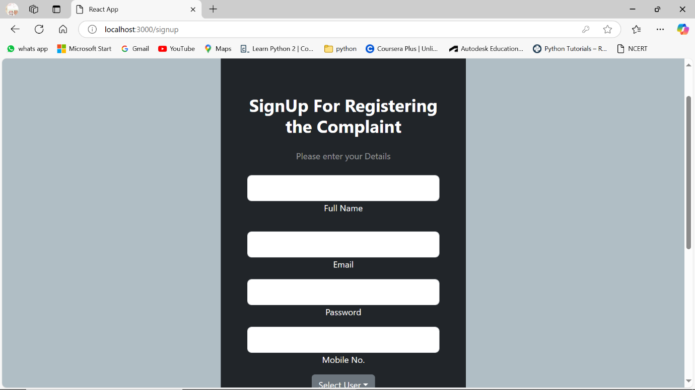

* **Common Dashboard For Complaint**

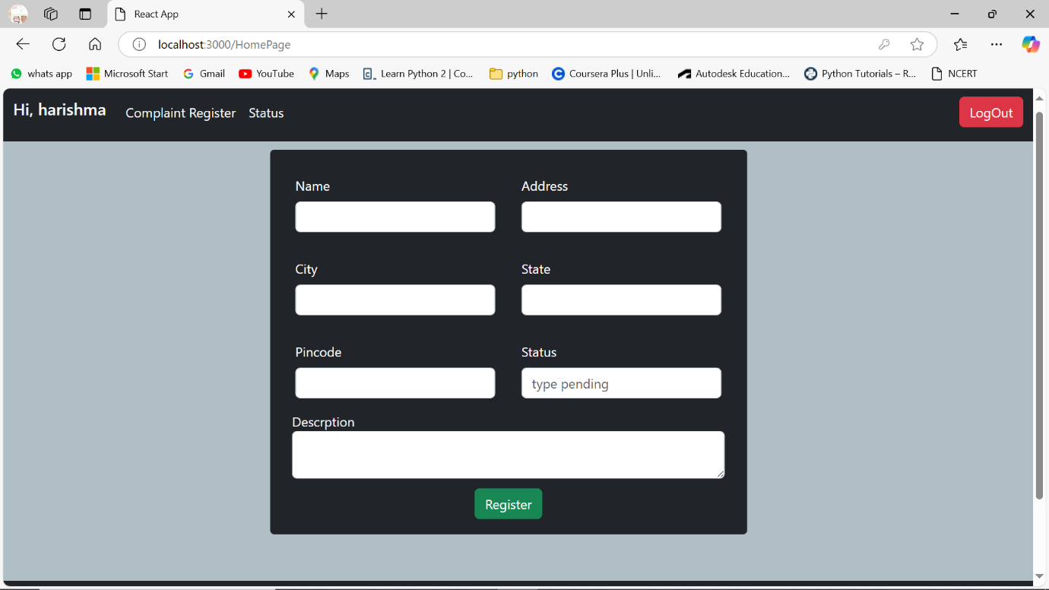

* **Admin Dashboard**

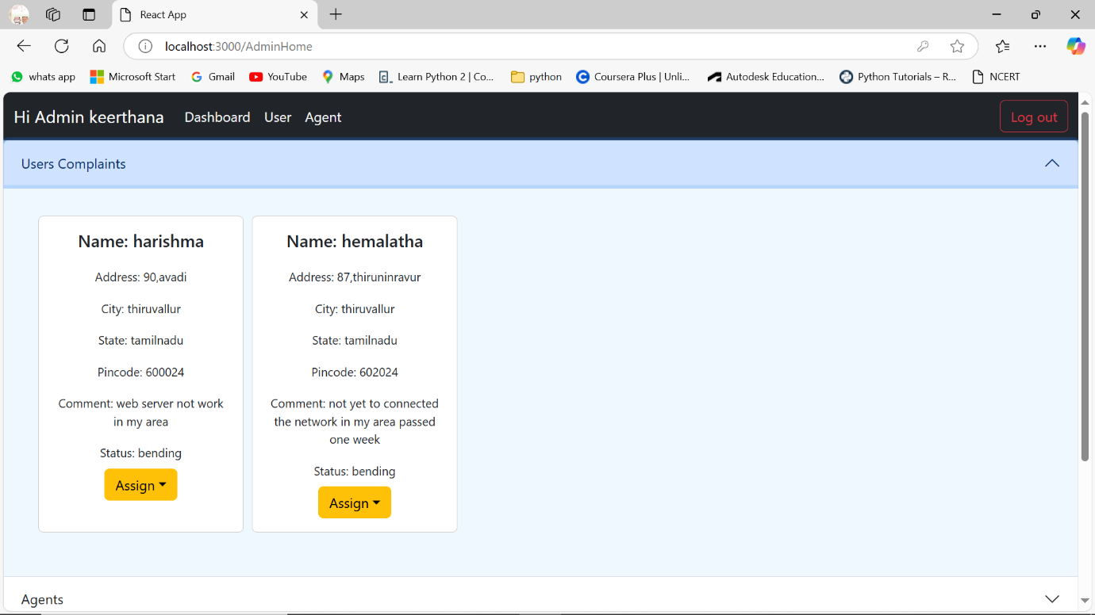

* **Agent Dashboard**

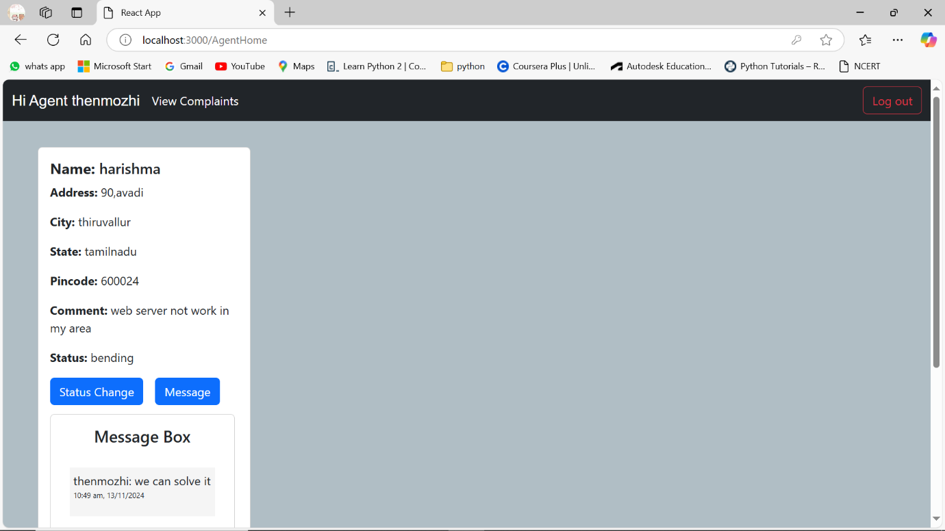

* **Additional features**

**User Complaint Status**

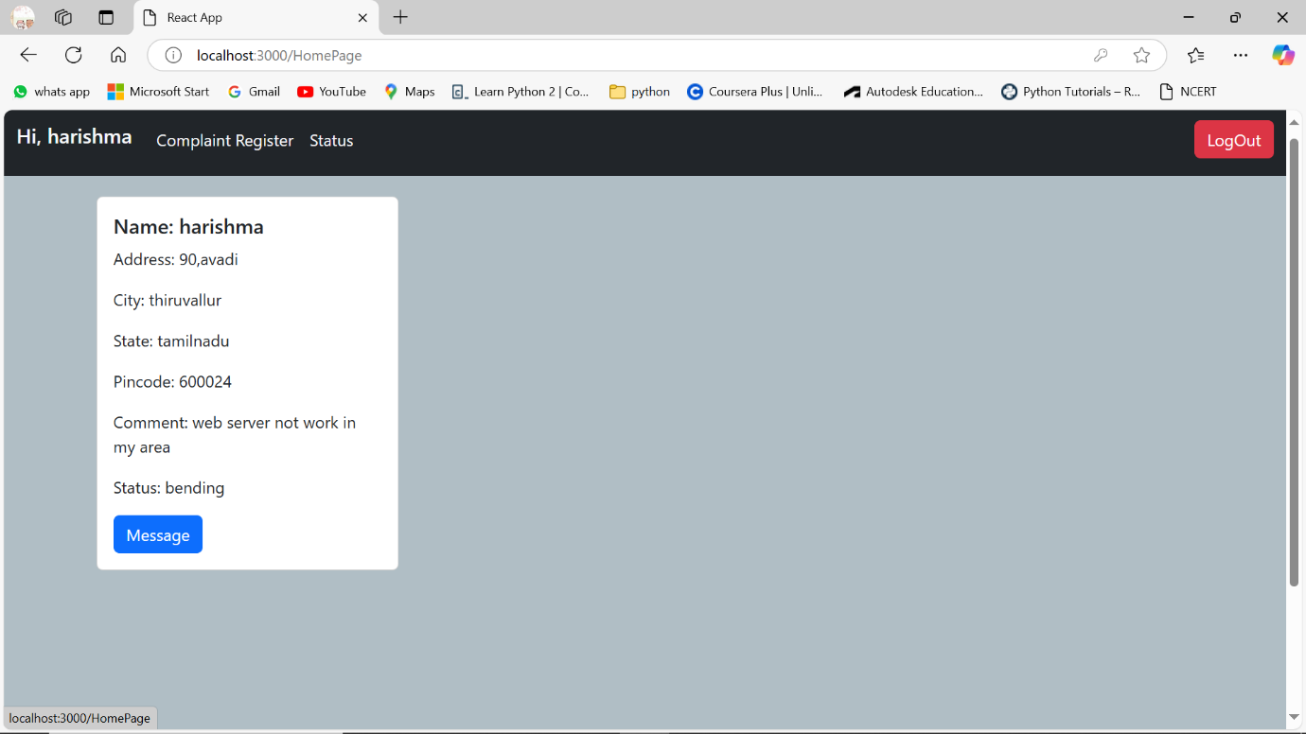

**Agent complaints view**

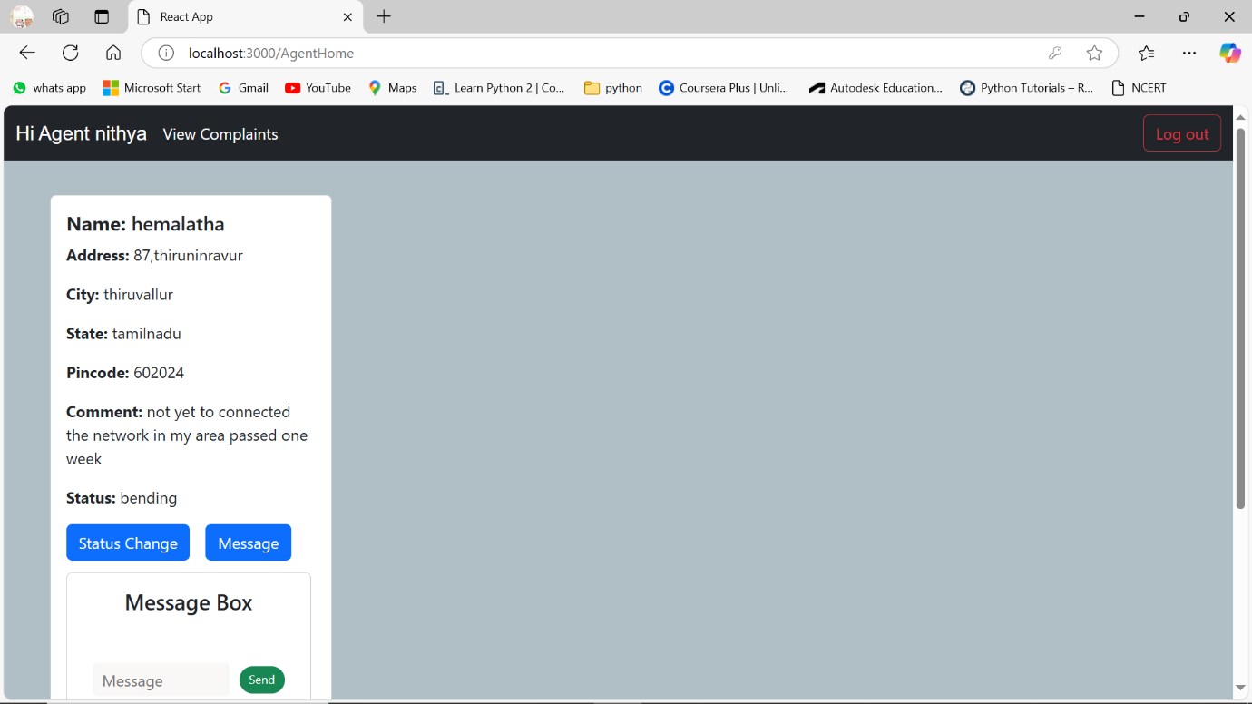



**List of agents**

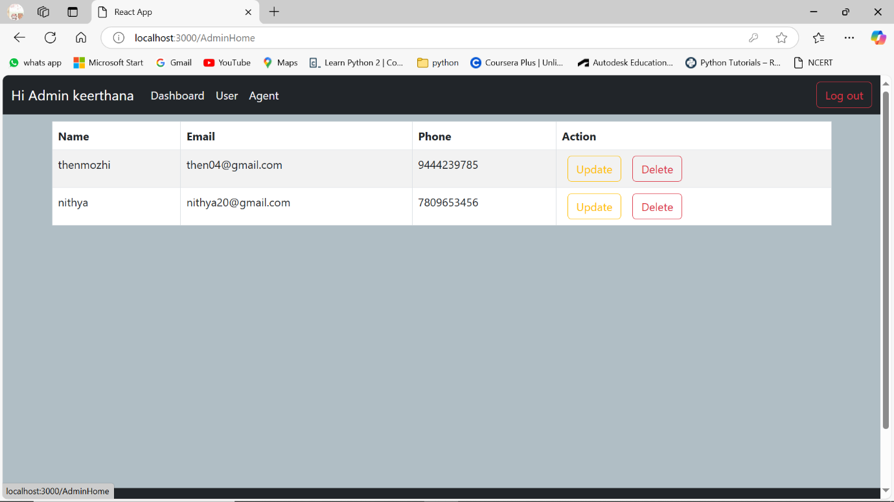

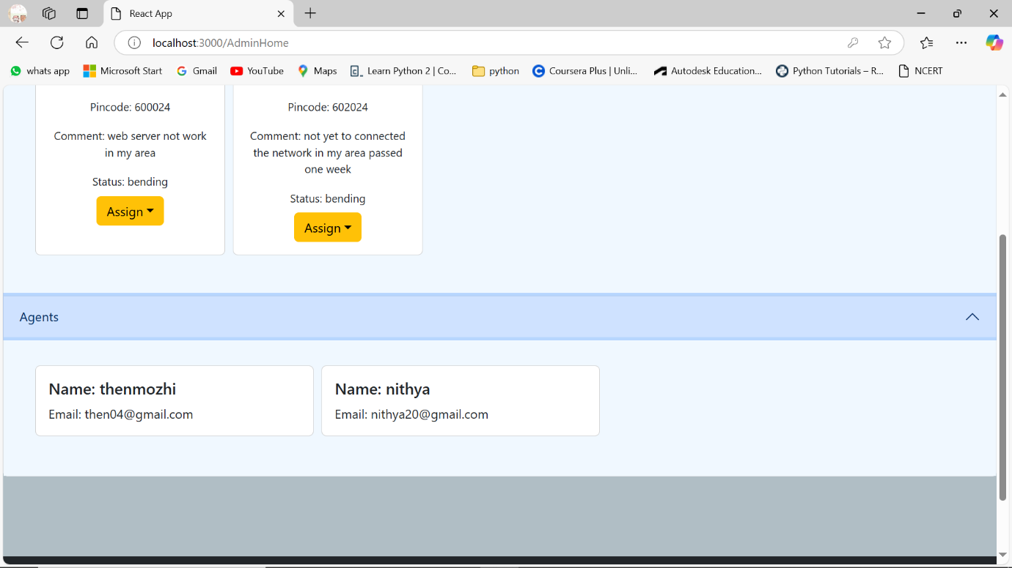

**List of users**



